IDEATION PHASE – DOCUMENT 1: BRAINSTORMING
Date | 06 November 2025
Team ID | NM2025TMID08097
Project Name | To supply Leftover Food to Poor
Maximum Marks | 4 Marks

Title: Brainstorming for “FoodConnect – To Supply Leftover Food to Poor”

1. Objective
The purpose of the brainstorming phase is to generate and evaluate multiple ideas for addressing the critical problem of food wastage and hunger.
This session aims to bring together creative thinking, social awareness, and technical feasibility to develop a solution that leverages digital tools—specifically Salesforce—to create social impact.

2. Brainstorming Process
The brainstorming process was conducted in three rounds:
- Ideation Round 1: Gathering ideas from general perspectives — how can technology help reduce food wastage?
- Ideation Round 2: Filtering ideas that align with feasibility and available tools.
- Ideation Round 3: Refining selected ideas into concrete, actionable solutions using Salesforce.
Each round included a mix of discussions, concept sketches, and digital whiteboard activities using tools like Miro and Google Jamboard.

3. Stakeholders Involved
Stakeholder | Role in Brainstorming | Contribution
Donors (Restaurants/Caterers) | Provide insights into how surplus food is handled | Identified donation logistics challenges
NGO Representatives | Explain the ground-level needs and constraints | Helped define distribution network
Volunteers | Provide real-life experience from fieldwork | Suggested app usability requirements
Technical Advisors | Salesforce mentors and faculty | Guided platform selection and architecture
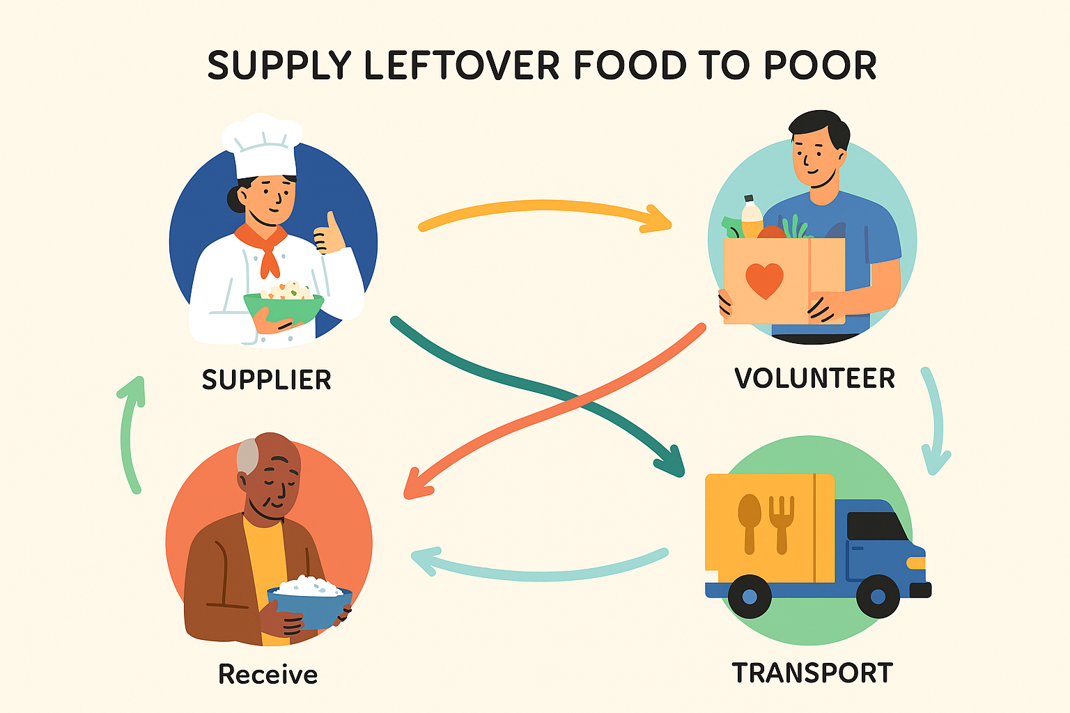

4. Idea Generation Methods
The following methods were applied during brainstorming:
- Mind Mapping: A visual map connecting “Food Wastage” → “Collection Process” → “Distribution” → “Tracking.”
- SCAMPER Technique: Focused on Substitute, Combine, Adapt, Modify, Put to another use, Eliminate, and Reverse existing donation workflows.
- Reverse Brainstorming: Instead of asking “How to donate food effectively?”, the question was reversed to “What causes food donation to fail?” to find root inefficiencies.

5. Consolidated Ideas
Idea No | Idea Description | Feasibility | Impact
1 | Mobile app for food pickup and donation | High | High
2 | Real-time volunteer tracking | High | High
3 | AI prediction of surplus food generation | Medium | Very High
4 | Salesforce automation for donation tasks | Very High | High
5 | Blockchain-based verification of donations | Medium | Moderate
After evaluation, Salesforce-based automation was selected for immediate implementation due to its:
- Readily available free developer environment
- Powerful automation tools (Flows, Triggers, Dashboards)
- Cloud scalability and security

6. Rationale for Choosing Salesforce
Salesforce provides a low-code/no-code environment that is ideal for social projects. It supports:
- Custom Objects to represent Venues, Tasks, Volunteers, etc.
- Flows for automating donation collection.
- Dashboards to measure impact (number of people served, food saved).
- Scalability for adding more NGOs or volunteers later.

7. Outcome of Brainstorming
The final concept, FoodConnect, emerged as a Salesforce-driven ecosystem that digitizes and automates food redistribution.
It offers a structured model to:
- Connect donors and volunteers in real time,
- Optimize food collection logistics, and
- Provide analytics for NGOs to assess impact.

